NETWORK FUNDAMENTALS AND BUILDING NETWORKS

Assignment day2

TASK1: Open Wireshark, capture network traffic while you refresh the Flipkart homepage, and identify one packet each belonging to the Application, Transport, Internet, and Network Access layers by examining their headers
- Opened Wireshark on my laptop.
- Selected the active Wi-Fi network interface.
- Clicked Start Capture.
- Opened www.flipkart.com in my browser and refreshed the homepage.
- Returned to Wireshark and clicked Stop Capture.
- Examined the captured packets and identified protocols from different TCP/IP layers.

TCP/IP Layer | Protocol | Reason
Application Layer | HTTPS | Used for secure communication with Flipkart website.
Transport Layer | TCP | Responsible for reliable delivery of data packets.
Internet Layer | IP | Contains source and destination IP addresses.
Network Access Layer | Ethernet II | Transfers data over the local network using MAC addresses.

TASK2: Create a table comparing the OSI and TCP/IP models, listing all layers side-by-side, and for each layer, give a real-world example from any app you use (e.g., WhatsApp message, Zomato order).
OSI Model | TCP/IP Model | Real-World Example
Application | Application | Sending a WhatsApp message
Presentation | Application | Instagram images and HTTPS encryption
Session | Application | Logging into Instagram
Transport | Transport | TCP delivering WhatsApp messages
Network | Internet | Router forwarding IP packets
Data Link | Network Access | Switch sending frames using MAC addresses
Physical | Network Access | Wi-Fi signals or Ethernet cable

TASK3: Given a screenshot of a TCP segment header (provided by your trainer), label the fields that belong to the Transport layer and explain what each field does in 1-2 lines.<br><br><em><strong>Hint:</strong> Look for fields like Source Port, Destination Port, Sequence Number, etc.</em>
Field | Function
Source Port | Identifies the sending application.
Destination Port | Identifies the receiving application.
Sequence Number | Keeps packets in the correct order.
Acknowledgment Number | Confirms that data has been received successfully.
Window Size | Controls the amount of data sent before receiving acknowledgment.
Checksum | Detects errors in transmitted data.
Flags (SYN, ACK, FIN) | Used to start, maintain, and end TCP connections.

TASK4: Draw a diagram showing how a message sent from your device to Instagram's server passes through each TCP/IP layer, and annotate what happens at each step using simple app-related terms (e.g., 'message split into packets', 'IP address added', etc.).
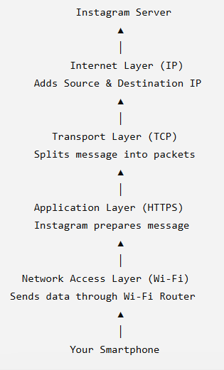

TASK5: Pick any one packet you captured in Wireshark and write which TCP/IP layer it belongs to, how you identified it, and what real-world action in an app (like sending a WhatsApp message or booking a ticket on BookMyShow) it represents.
I selected an HTTPS packet from my Wireshark capture.
- TCP/IP Layer: Application Layer
- How I Identified It: The Protocol column showed HTTPS, indicating secure communication between my browser and the Flipkart server.
- Real-World Example: This packet represents loading the Flipkart homepage or placing an order securely through the website.

